

**Caythorpe Chronicle**

**Friday 23rd February 2024**



Monday 26 February – Fitness Profiling

Wednesday 28th February – Hogwarts Starlincs Planetarium Visit

Thursday 29th February – Y5/6 Substance Awareness workshop

Thursday 7th March – **World Book Day, Dress up and** **book swap**

Friday 8th March – Wrates class photos

Sunday 10 March – 9.45 am Mothering Sunday service at Fulbeck church

Monday 11th March – British Science Week begins

Friday 15 March – Comic Relief

Monday 25 March – Rock Steady concert

Tuesday 26th March – Parents’ evening

Wednesday 27th March – Parents’ evening

Thursday 28th March – Term 4 ends

Monday 15th April – Staff Training

Tuesday 16th April – Term 5 Begins

Monday 6th May – Bank Holiday

Monday 13th May – Year 6 SATs week.

Friday 24th May – Term 5 Ends

Monday 3rd June – Term 6 Begins

Tuesday 25th June – School Games Day

Monday 1st – Wednesday 3rd July – Y4,5,&6 Residential to the Hollowford Centre, Castleton

Friday 12th July – French day

Saturday 13th July – Caythorpe School Fayre – 1-4pm

Monday 15th July – Rock Steady Summer performance

Friday 19th July – End of term awards 11.15am and whole school picnic

**Spring Term 2 Topics**

Neverland started off their topic “What makes the Fire of London so Great?” with a big bang! They found out that the Fire of London began in a street called Pudding Lane. They then made some bread rolls fit for a King! They also made sure they had turned off the oven.

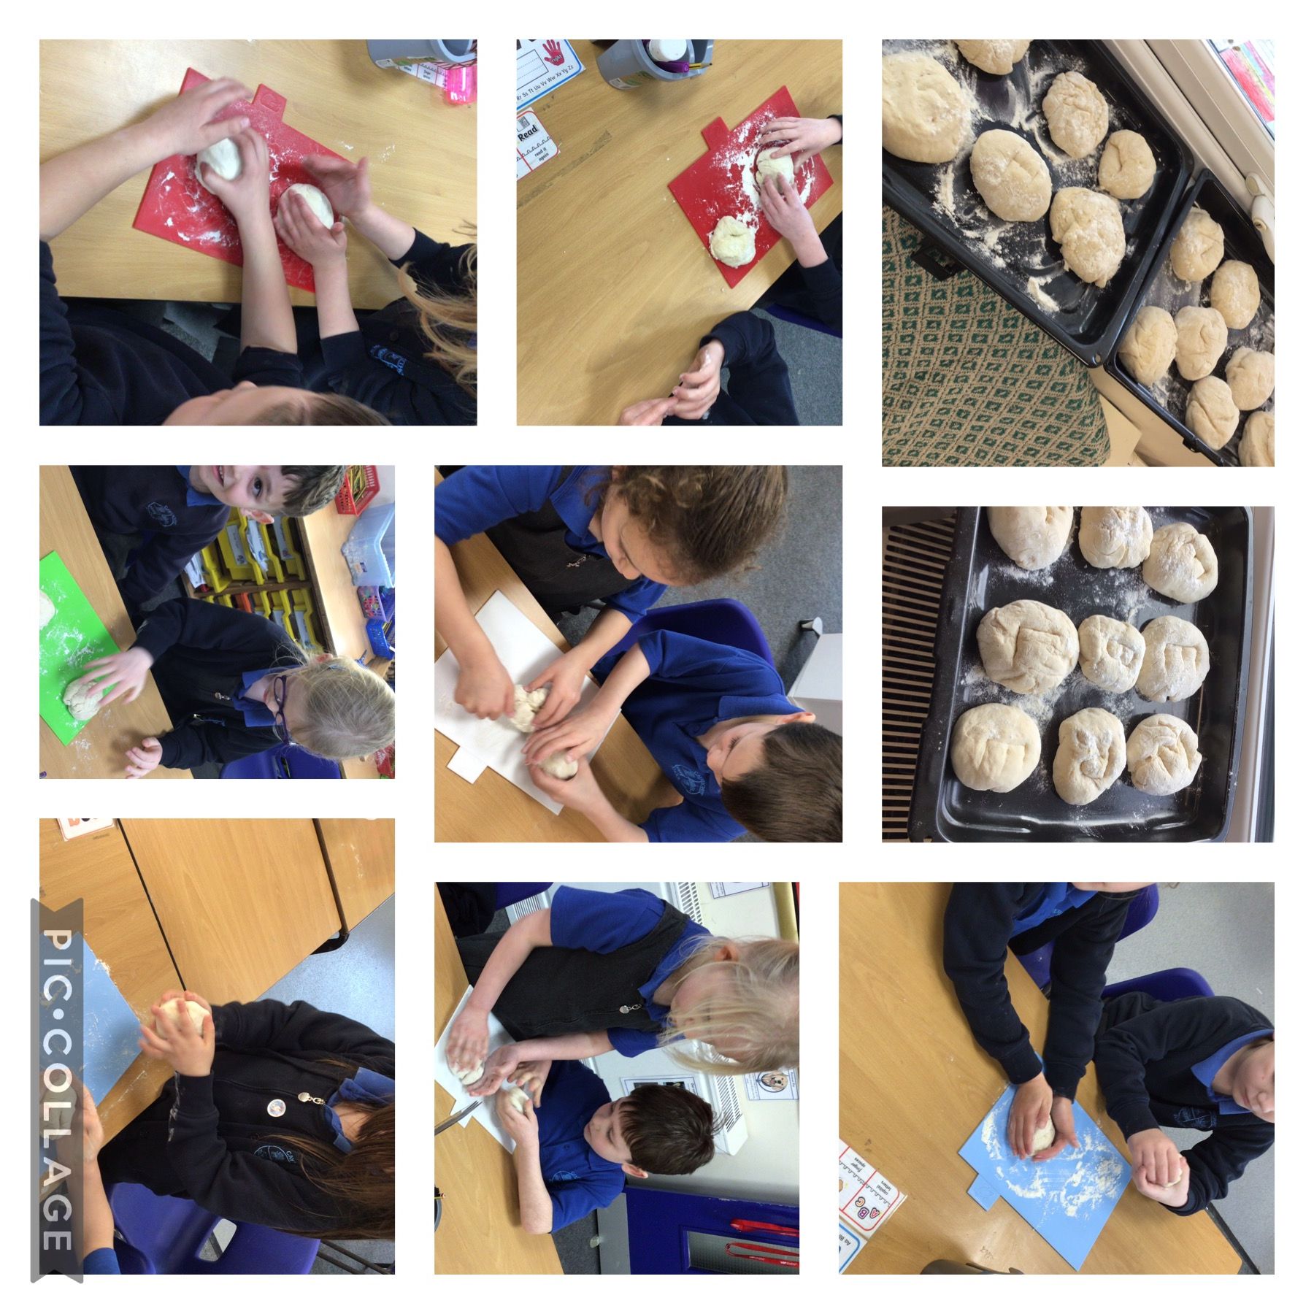

**Narnia Homework**

Narnia have created some amazing homework projects inspired by their topic “Where is Caythorpe in Europe?”

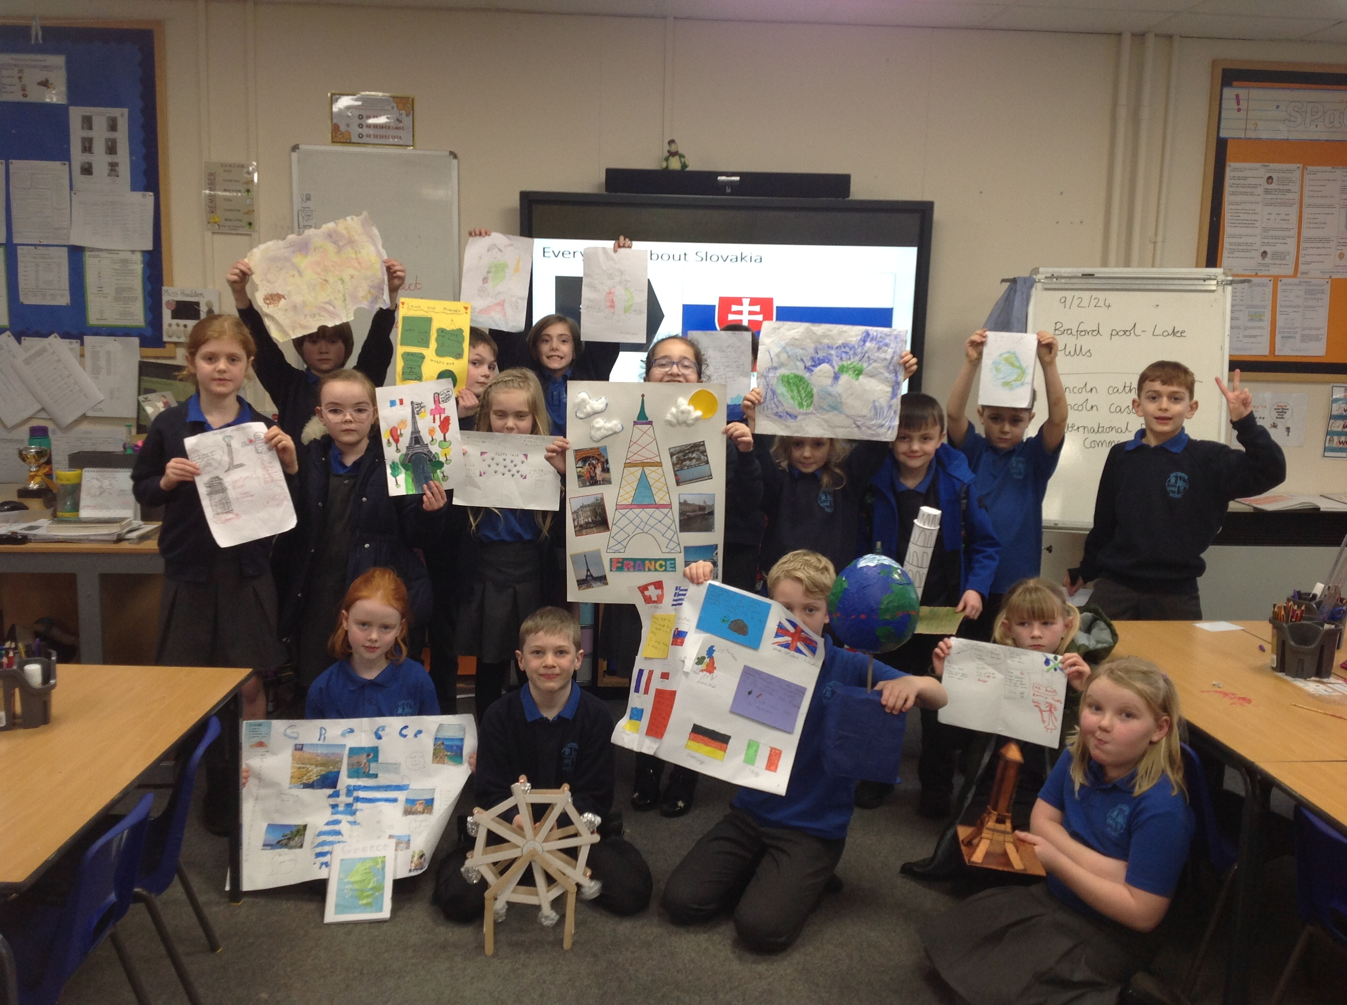

**Relationship and Sex Education (RSE)**

We are reviewing our RSE Policy. From September 2020, schools have been required to teach RSE to pupils from the age of four onward. Primary-aged children will be taught relationships education only. We have a clear RSE curriculum in place, which is planned and outlined according to government criteria. We feel the current curriculum is still fit for purpose, however, we understand the important role parents play in enhancing their children’s understanding of relationships, sex and health. Similarly, we also understand how important parents’ views are in shaping the curriculum.

After kindly taking the time to read our RSE policy, we would be grateful if you could fill out the questionnaire [following this link.](https://bit.ly/caythorpe-rse24)

Before half term, **Hogwarts** had the highest attendance with 94%. Overall attendance was 91%. National expectation is 94%. All 100% attendees this week have been added to the Easter draw for a chance to win the £10 amazon gift card!

**Spring Term’s Reading Winners**

Congratulations to last term’s reading winners, Rory, Isla, Crystal and Jack. All children who receive a honeycomb for 10 reads are entered into the draw. Children will find out next term’s books in Tuesday assemblies. Get reading and collecting those honeycombs for more chances to be in the draw.

***PARENT WORKSHOP “How to keep your autistic child safe from online radicalisation”.***



*This is a free online workshop, designed specifically for parents, carers, and those who provide direct support for neurodiverse children, particularly males.*

*The workshop contents will include:*

* *Understanding the specific vulnerabilities of young males with ASD or other neurological conditions which makes them particularly susceptible to radicalisation.*
* *Identify when a young person in your care, or who you support, is at risk of online radicalisation.*
* *Provide the skills and knowledge to intervene directly in an appropriate way to safeguard the young person.*
* *Know how to seek further support in mitigating that risk.*

*Workshop dates are yet to be planned but are likely to be during April / May, held online, for approximately 2 hours.  LSCP welcome any feedback on what times of day would be most suitable for these to take place.*

*To express an interest in being allocated a place on one of the workshops please email* [*Prevent@lincolnshire.gov.uk*](mailto:Prevent@lincolnshire.gov.uk) *with your contact details and a brief description of how the course may be suitable for you.*

**Sports Hall Athletics Competition**

**

Poppy, Isabella, Florrie, Colette, Olivia, Jess M, Alex, Tom, Jack B, Mason and Albert all took part in the Small School’s Sports Hall Athletics competition on Friday 9th February at Carres Grammar School.

The boy’s strongest event was the obstacle relay where they were winners of their heat. The girls were just pipped at the post and came in second in the obstacle and 2x2 relay events.

Despite not being placed, it was wonderful to see the children encourage each other as well as children from other schools.

Thank you to parents who supported with transport to and from the event so the children could take part. Colette said she, “really enjoyed the event and was glad she went!”

**Narnia Swimming**



Y3s and 4’s are swimming again this term and the cost is £3.80 per session or £22.80 for the term, which can be paid termly or weekly.  We would also be grateful if all contributions for the first half of the term could be paid as soon as possible please.